
Farm Woodland Assessment
Application Form

If you are interested in receiving one of a limited number of free Farm Woodland Assessments, please complete this form and return to will.chadwick@forestry.gov.scot
Please note that the land to be assessed must be within the area shown in the below map.
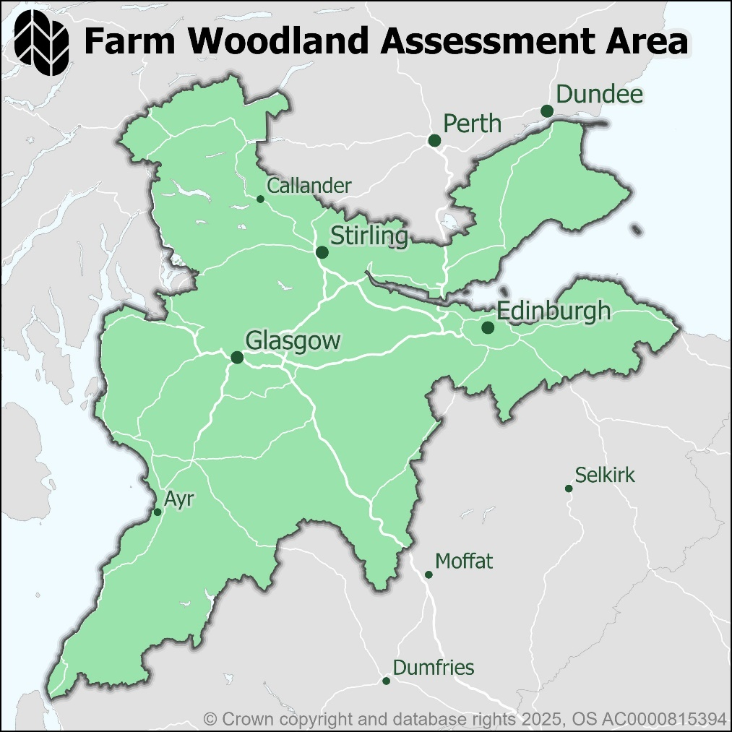

- CONTACT DETAILS
Contact Name | Click or tap here to enter text.
Address | Click or tap here to enter text.
Telephone | Click or tap here to enter text.
Email | Click or tap here to enter text.

- PLANTING LOCATION
Farm Name | Click or tap here to enter text.
Farm Address | Click or tap here to enter text.
Farm Postcode | Click or tap here to enter text.
Grid Reference | Click or tap here to enter text.
Local Authority | Click or tap here to enter text.

- OWNERSHIP DETAILS (tick)
Landowner | ☐
Tenant | ☐
Neither | ☐

If neither, what is your relationship to the landowner?
Click or tap here to enter text.

- MORE ABOUT YOUR FARM BUSINESS
What is your BRN? | Click or tap here to enter text.
What is your MLC? | Click or tap here to enter text.
What kind of farm / farming business do you have? | Click or tap here to enter text.
What size is your farm? | Click or tap here to enter text. Ha
Do you have an IACS map? | YES / NO
Why are you thinking about woodland creation? | Click or tap here to enter text.

E. WHERE YOU ARE CONSIDERING PLANTING
Have you already identified a site or location for the planting? | YES / NO
If YES what is the area of land identified? | Click or tap here to enter text. Ha
Are there any known constraints to tree planting? | YES / NO / DON’T KNOW
If YES, please specify | Click or tap here to enter text.

Please return your completed form to will.chadwick@forestry.gov.scot

